Tribal Weavings of the Lesser Sunda Islands

The most exciting textile tour you are ever likely to find – the trip of a lifetime!

The remote ikat-weaving islands of eastern Indonesia have one of the most diverse textile cultures on the planet. Hand-woven cloth plays a pivotal role in the cohesion of all these societies, cementing clan alliances through complex gift exchanges, revealing tribal loyalties and underpinning the annual cycle of rituals. As some islanders emphasize: ‘without cloth we cannot marry’.

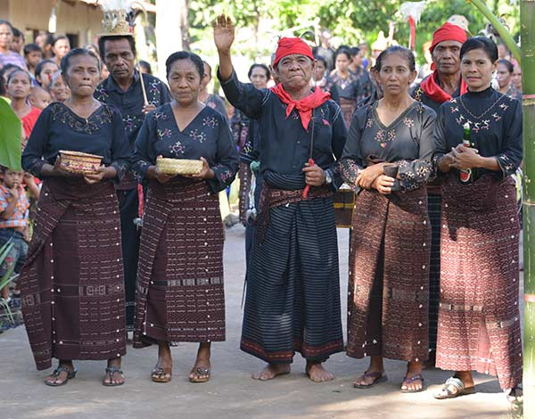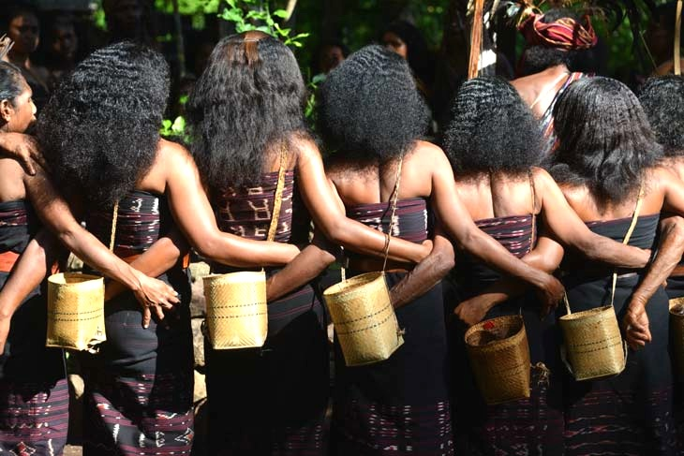

Sadly the encroachment of the modern world means that the number of communities where women still continue to spin their own cotton, prepare their own natural dyes and weave on traditional back-tension looms is limited. Their numbers are dwindling and within a generation they could be gone.

Join British textile experts David and Sue Richardson for a fantastic, adventurous voyage on a traditionally designed Indonesian schooner (phinisi), custom-built by Buginese shipbuilders. With a maximum of 22 passengers, our American-owned boat has all modern amenities with comfortable en-suite air-conditioned cabins, lots of shaded deck space, an enclosed lounge and bar, and all the latest safety equipment.

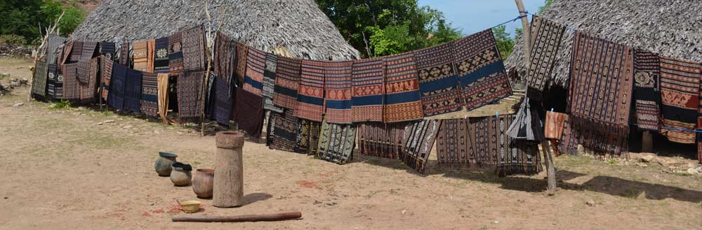

Our itinerary takes us along the coast of Flores and on to the islands of Lembata, Ternate, Alor, Pantar, Savu, Raijua, and Sumba, returning via Rinca to visit the Komodo dragons. In village after village we will see every aspect of ikat production and natural dyeing and have the opportunity to purchase fabulous textiles directly from the women who made them. Before each visit guests will be fully briefed so that they completely understand the type of textiles and techniques they will encounter and the role that cloth plays within the local community. Our journey will take us through a dramatic volcanic landscape during which there will be time to write-up journals, relax, swim, snorkel, sunbathe and beachcomb.

Our cruise begins at Maumere on the island of Flores on May 14, 2020 and ends at Labuan Bajo, also on Flores on May 25, 2020. Both places are connected to Bali by short direct flights.

This is going to be a fun trip - we hope that you can join us.

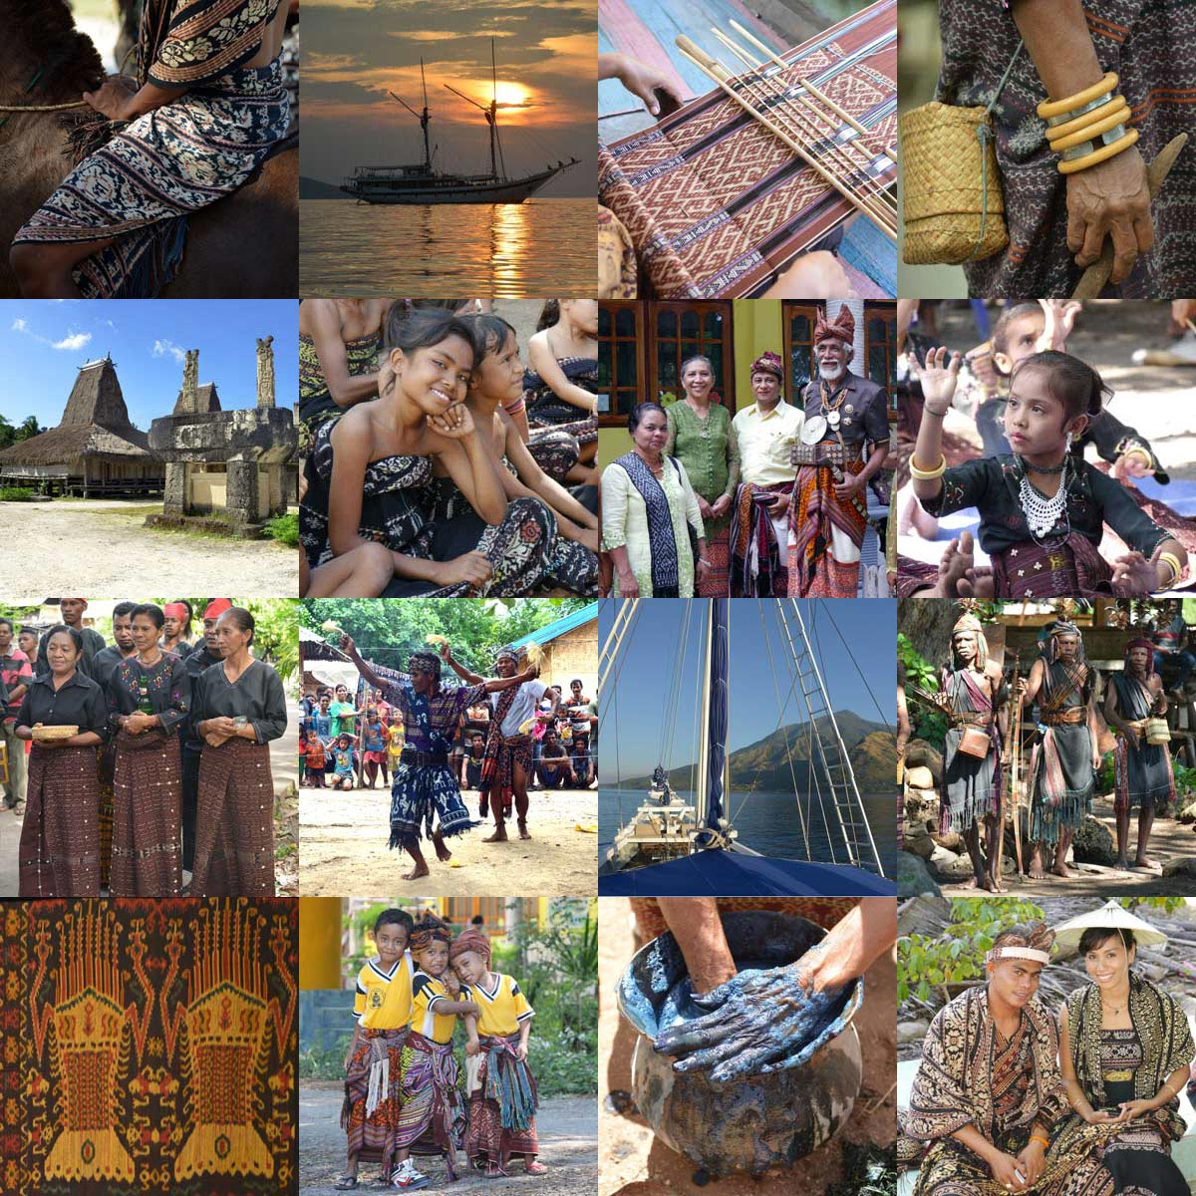

For more information contact David and Sue Richardson at davidandsue@asiantextilestudies.com or visit http://www.asiantextilestudies.com/tour.html

David and Sue Richardson have been studying and writing about the textiles of Southeast and Central Asia for thirty years, during which time they have visited almost every part of the Indonesian archipelago. They are active members of the Oxford Asian Textile Group, linked to the Ashmolean and Pitt Rivers Museums in Oxford, and of the Anglo-Indonesian Society. Their latest major work, Qaraqalpaqs of the Aral Delta, was published by Prestel in 2012.

